# Fisheries Natura Risk Mitigation Plan

# Fishery

# Dredge fishing for Scallop and Bottom towed gears

# SACs

# Mullet/Blacksod SAC

**June 15th 2015**

(This draft mitigation plan was developed by the Marine Institute in consultation with DAFM, BIM, NWRIFF, Erris Inshore Fishermen’s Association, ELCRA, Achill fishermen, Blacksod Bay oyster co-op members. Details of the consultation process are provided in Annex II)

# Scallop fishing on habitats in the SACs

## Profile of activity

Scallop have been fished by inshore fishing vessels in Blacksod Bay for a number of years. Fishing in spring of 2015 involved at least 12 vessels. No data are currently available on landings or effort. No stock assessments have been undertaken for this fishery.

The Marine Institute (2015) Natura-Fisheries risk assessment report indicated that the scallop fishery was located in the south of the Bay (see Annex I). This information was based on best estimates of the location of the fishery from information obtained in 2013. Data on oyster fisheries were obtained from survey data and for other fisheries from expert opinion of various people.

These fisheries overlap individual habitats within the Bay to varying extent and pose a risk to some sensitive habitats in particular (Annex I).

## Potential overlap of scallop fishing with habitats in the SACs.

Marine Habitats in Mullet/Blacksod Bay SAC are shown in Figure 1.

An assessment of the risk posed by dredging for scallops and other fisheries on habitats in Mullet/Blacksod SAC is included in Marine Institute (2015) which profiles the risks posed by all fisheries in all marine SACs in Ireland (see Annex I). This assessment uses a specific risk assessment framework designed to assess risk relative to the conservation objectives set for habitats and species by the NPWS.

Mullet / Blacksod SAC is designated for the following qualifying interests

* Mudflats and sandflats not covered by seawater at low tide [1140]
* Large shallow inlets and bays [1160]
* Reefs [1170]
* Salicornia and other annuals colonising mud and sand [1310]
* Shifting dunes along the shoreline with Ammophila arenaria (white dunes) [2120]
* Fixed coastal dunes with herbaceous vegetation (grey dunes) [2130]
* Atlantic decalcified fixed dunes (Calluno-Ulicetea) [2150]
* Machairs (* in Ireland) [21A0]
* Natural eutrophic lakes with Magnopotamion or Hydrocharition - type vegetation [3150]
* Alkaline fens [7230]
* Lutra lutra (Otter) [1355]
* Petalophyllum ralfsii (Petalwort) [1395]

Scallop fishing does not overlap or have significant effects on

* Salicornia and other annuals colonising mud and sand [1310]
* Shifting dunes along the shoreline with Ammophila arenaria (white dunes) [2120]
* Fixed coastal dunes with herbaceous vegetation (grey dunes) [2130]
* Atlantic decalcified fixed dunes (Calluno-Ulicetea) [2150]
* Machairs (* in Ireland) [21A0]
* Natural eutrophic lakes with Magnopotamion or Hydrocharition - type vegetation [3150]
* Alkaline fens [7230]
* Lutra lutra (Otter) [1355]
* Petalophyllum ralfsii (Petalwort) [1395]

As scallop are not common in intertidal waters Scallop fishing is unlikely to overlap with

* Mudflats and sandflats not covered by seawater at low tide [1140]

Scallop fishing may overlap therefore only with

* Large shallow inlets and bays [1160]
* Reefs [1170]

Within qualifying interests 1160 and 1170 there are a number of marine habitats or communities. In Mullet / Blacksod Bay SAC these are

* Sand with Gastrosaccus spinifer community complex
* Fine sand with Angulus fabula community complex
* Zostera-dominated community
* Maërl-dominated community
* Serpula vermicularis-dominated community complex
* Sheltered subtidal reef community complex
* Laminaria-dominated community complex
* Shingle
* Intertidal reef community complex
* Sand with Angulus tenuis and Pygospio elegans community complex (intertidal)
* Mobile sand with Bathyporeia guilliamsoniana community (intertidal)

As scallop do not occur in the following habitats fishing will not overlap with them

* Shingle
* Intertidal reef community complex
* Sand with Angulus tenuis and Pygospio elegans community complex (intertidal)
* Mobile sand with Bathyporeia guilliamsoniana community (intertidal)

Scallop fisheries may therefore potentially overlap only with the following habitats

* Sand with Gastrosaccus spinifer community complex
* Fine sand with Angulus fabula community complex
* Zostera-dominated community
* Maërl-dominated community
* Serpula vermicularis-dominated community complex
* Sheltered subtidal reef community complex
* Laminaria-dominated community complex

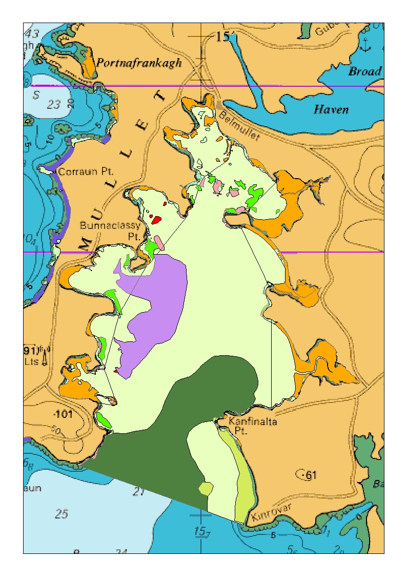



Figure 1. Marine Habitats in Mullet/Blacksod bay SAC (source: NPWS geodatabase April 2015)

## Guidance on specific conservation objectives for marine habitats

The conservation targets established by NPWS for marine communities recognises that such habitats have different sensitivities to physical disturbance. In this respect there are two important and separate components of habitat sensitivity that are relevant to the mitigation of risk posed by scallop fishing. Sensitivity is a composite of the resistance and resilience of a habitat when exposed to a physical pressure such as scallop dredging. It is clear from various studies that few habitats have any significant resistance to the surface and sub-surface benthic pressures caused by scallop gear. However, habitats vary in their resilience to such pressure in that some habitats can recovery more quickly than others. The rate of recovery following a disturbance is an important consideration in that habitats which show rapid recovery could be in good condition even if disturbed frequently whereas habitats with poor recovery could only be disturbed very infrequently if the objective was to maintain them in good condition. As outlined in the conservation objective guidance documents from NPWS the scale of disturbance (the % of the habitat that is disturbed) and the persistence of the disturbance is relevant to achievement of favourable conservation status of habitats. The conservation status is reported to the EU Commission every 6 years as directed by Article 17 of the Habitats Directive.

In the case of Mullet / Blacksod SAC habitats the conservation objective targets published by NPWS are related to the sensitivity of the habitats to fishing gears (Table 1).

## Mitigation plan

1. Scallop fishing will be excluded, or in effect does not occur anyway, from the following habitats (Table 1) and will be limited to the area defined by the co-ordinates shown in Table 2 and Figure 2.
   1. Seagrass
   2. Maerl
   3. Serpula vermicularis
   4. Sheltered subtidal reef community complex
   5. Mobile sand with B. Guilliamsoniana community
2. Scallop fishing will potentially occur on
   1. Sand with Gastrosaccus spinifer community complex
   2. Fine sand with Angulus fabula community complex
   3. Laminaria-dominated community complex

The fishery will overlap with more than 15% of sand habitats (2a,b above). To maintain these habitats in favourable conservation status the fishing season will be limited so that the significant habitat disturbance caused by scallop dredging is not persistent.

1. The fishing season will extend from oct 1st to Feb 28th.

In the case of Laminaria reef a small area occurs within the fishing area but is unlikely to be affected by scallop dredging as it is not feasible to fish the reef with scallop dredges.

1. To monitoring and enforce the closed area and the fishing season all vessels participating in the scallop fishery will be required to carry an approved GPS tracking device. These will be supplied and fitted by the Marine Institute and subsequently monitored by the SFPA for control and enforcement purposes and by the Marine Institute to map the distribution of fishing effort in the Bay.

Table 1. Conservation targets and options for management of towed bottom gears on different habitats in Mullet/Blacksod SAC

|  |  |  |  |  |  |  |
| --- | --- | --- | --- | --- | --- | --- |
|  | **Conservation objectives** | |  | **Management options** | | **Management measure** |
| **Habitat** | **Area (ha)** | **Target** | **Habitat sensitivity** | **1** | **2** |  |
| Zostera-dominated community | 170 | No disturbance | High | No bottom towed gears |  | Closed areas |
| Maërl-dominated community | 14 | No disturbance | High | No bottom towed gears |  | Closed areas |
| Serpula vermicularis-dominated community complex | 855 | No disturbance | High | No bottom towed gears |  | Closed areas |
| Fine sand with Angulus fabula community complex | 1182 | persistent disturbance <15% of area; non-persistent disturbance case by case assessment | Low | Limit overlap of habitat and dredging <15% | Limit disturbance in balance with habitat resilience | Seasonal or less frequent fisheries; effort limits on >15% of habitat |
| Sand with Gastrosaccus spinifer community complex | 1994 | persistent disturbance <15% of area; non-persistent disturbance case by case assessment | Low | Limit overlap of habitat and dredging <15% | Limit disturbance in balance with habitat resilience | Seasonal or less frequent fisheries; effort limits on >15% of habitat |
| Sand with Angulus tenuis and Pygospio elegans community complex | 6289 | persistent disturbance <15% of area; non-persistent disturbance case by case assessment | Low | Scallop fishing does not occur on this habitat |  | No action |
| Intertidal reef community complex | 254 | persistent disturbance <15% of area; non-persistent disturbance case by case assessment | Moderate | Scallop fishing does not occur on this habitat |  | No action |
| Sheltered subtidal reef community complex | 81 | persistent disturbance <15% of area; non-persistent disturbance case by case assessment | Moderate | Limit overlap of habitat and dredging <15% | Limit disturbance in balance with habitat resilience | Closed areas |
| Laminaria-dominated community complex | 251 | persistent disturbance <15% of area; non-persistent disturbance case by case assessment | High | Scallop fishing does not occur on this habitat |  | Fishing is not likely to occur on Laminaria reef. Over 85% of Laminaria reef is excluded from the fishing area |
| Shingle | 38 | persistent disturbance <15% of area; non-persistent disturbance case by case assessment | Low | Scallop fishing does not occur on this habitat |  | No action |

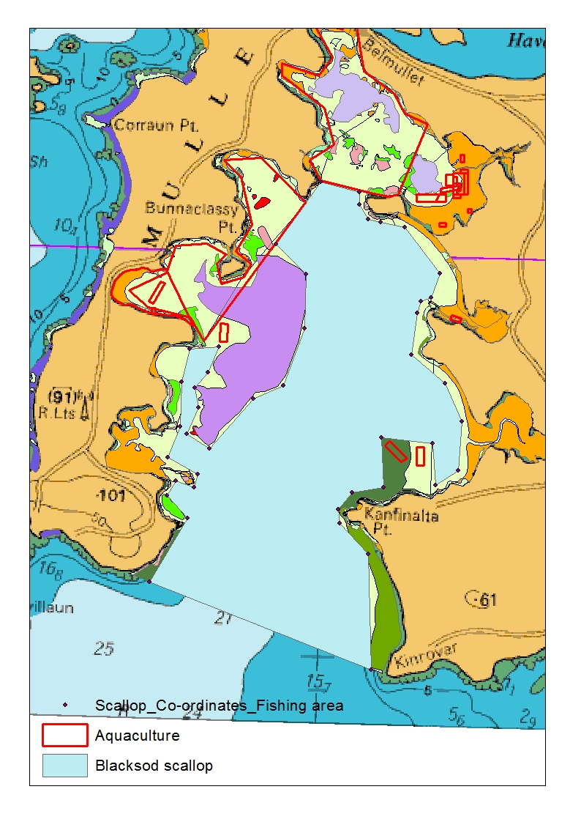

Figure 2. Proposed scallop gear fishing areas showing exclusion from sensitive habitats Maerl, seagrass and Serpula. Aquaculture licences or applications as of March 2015 are shown. Habitats where scallop gear is allowed will have limited fishing seasons. Scallop fishing is unrestricted south of the SAC.

Table 2. Co-ordinates defining the outer boundaries for scallop fishing in Mullet/Blacksod Bay SAC. Co-ordinate system: WGS84, Decimal degrees.

|  |  |
| --- | --- |
| Longitude | Latitude |
| -10.0053 | 54.1855 |
| - 9.9886 | 54.1833 |
| -9.9886 | 54.1801 |
| -9.9846 | 54.1766 |
| -9.9793 | 54.1759 |
| -9.9690 | 54.1747 |
| -9.9533 | 54.1634 |
| -9.9568 | 54.1573 |
| -9.9611 | 54.1563 |
| -9.9625 | 54.1533 |
| -9.9647 | 54.1429 |
| -9.9499 | 54.1360 |
| -9.9424 | 54.1267 |
| -9.9434 | 54.1143 |
| -9.9527 | 54.1106 |
| -9.9545 | 54.1210 |
| -9.9765 | 54.1220 |
| -9.9747 | 54.1096 |
| -9.9882 | 54.1081 |
| -9.9939 | 54.1037 |
| -9.9932 | 54.1004 |
| -9.9807 | 54.0928 |
| -9.9779 | 54.0639 |
| -10.0734 | 54.0842 |
| -10.0579 | 54.1006 |
| -10.0669 | 54.1060 |
| -10.0632 | 54.1098 |
| -10.0555 | 54.1083 |
| -10.0542 | 54.1116 |
| -10.0672 | 54.1155 |
| -10.0623 | 54.1234 |
| -10.0621 | 54.1346 |
| -10.0591 | 54.1427 |
| -10.0468 | 54.1435 |
| -10.0511 | 54.1370 |
| -10.0565 | 54.1332 |
| -10.0545 | 54.1283 |
| -10.0593 | 54.1215 |
| -10.0494 | 54.1181 |
| -10.0313 | 54.1307 |
| -10.0189 | 54.1343 |
| -10.0103 | 54.1487 |
| -10.0103 | 54.1623 |
| -10.0235 | 54.1696 |
| -10.0053 | 54.1855 |

# Annex I

## Fisheries Natura Risk assessment summary for Mullet/Blacksod SAC (from Marine Institute 2015)

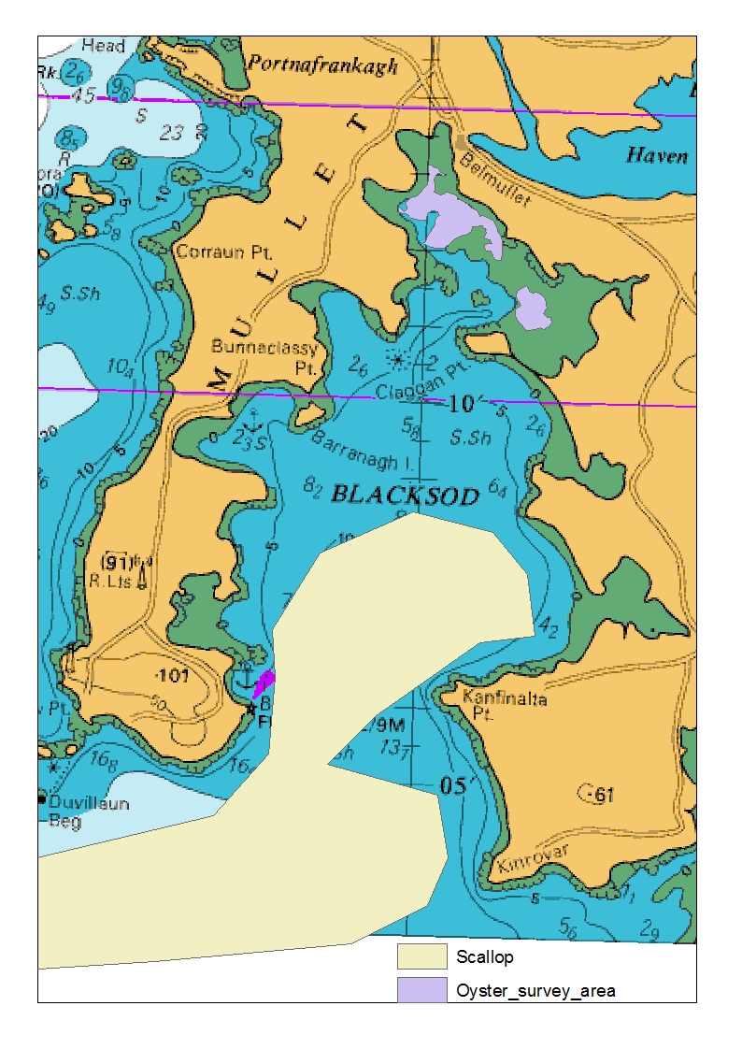

Figure 3. Distribution of scallop and oyster fishing used in the Marine Institute (2015) Natura-Fisheries risk assessment

Risk values 16 and over (red) require a mitigation plan. Values 9-12 may need to be considered for mitigation although in the case of shrimp pots on Serpulid reef this is unlikely

|  |  |  |  |  |  |  |
| --- | --- | --- | --- | --- | --- | --- |
| **Qualifying Interest** | **Marine Community Type** | **Description** | **Trap - shrimp** | **Trap - whelk** | **Dredge - scallop** | **Dredge oyster** |
| Mudflats and sandflats not covered by seawater at low tide [1140] | Mobile sand with Bathyporeia guilliamsoniana community | Sand |  |  |  |  |
| Mudflats and sandflats not covered by seawater at low tide [1140] | Sand with Angulus tenuis and Pygospio elegans community complex | Sand |  |  |  | 4 |
| Large shallow inlets and bays [1160] | Sand with Angulus tenuis and Pygospio elegans community complex | Sand |  |  |  | 4 |
| Large shallow inlets and bays [1160] | Sand with Gastrosaccus spinifer community complex | Sand | 4 | 4 | 12 |  |
| Large shallow inlets and bays [1160] | Fine sand with Angulus fabula community complex | Sand | 4 | 4 | 12 | 4 |
| Large shallow inlets and bays [1160] | Zostera-dominated community | Seagrass |  |  |  | 20 |
| Large shallow inlets and bays [1160] | Maërl-dominated community | Corraline algae |  |  |  |  |
| Large shallow inlets and bays [1160] | Serpula vermicularis-dominated community complex | Biogenic reef | 12 | 12 | 20 |  |
| Large shallow inlets and bays [1160] | Intertidal reef community complex | Reef |  |  |  | 16 |
| Large shallow inlets and bays [1160] | Sheltered subtidal reef community complex | Reef |  |  |  |  |
| Large shallow inlets and bays [1160] | Laminaria-dominated community complex | Kelp | 9 | 9 | 16 |  |
| Large shallow inlets and bays [1160] | Shingle | Shingle |  |  |  |  |
| Reefs [1170] | Serpula vermicularis-dominated community complex | Biogenic reef | 12 | 12 | 20 |  |
| Reefs [1170] | Intertidal reef community complex | Reef |  |  |  | 16 |
| Reefs [1170] | Sheltered subtidal reef community complex | Reef |  |  |  |  |
| Reefs [1170] | Laminaria-dominated community complex | Kelp | 9 | 9 | 16 |  |

# Annex II Consultation process during development of this mitigation plan

* The following attended a meeting in the Broadhaven Bay Hotel, Belmullet, June 2nd

Oliver Tully MI,

Ian Lawler BIM,

John Healy SFPA,

Tracy McPhelim SFPA,

Declan Nee BIM,

Eamon Dixon Chair NWRIFF,

Ciaran Quinn Vice Chair NWRIFF,

Mary Gavin Hughes NWRIFF,

Anthony Irwin NWRIFF,

David Johnston NWRIFF,

Pat Mulloy NWRIFF,

Micheal Kelly NWRIFF,

David Downes NWRIFF,

Caden O Donnell NWRIFF,

Willaim Walker NWRIFF and scallop Fisher (SF),

Pat Walker (SF),

Joe Walker (SF),

P J Walker(SF),

Micheal Walker (SF),

Martin Murphy (SF),

John Murphy (SF),

Charles O Malley Clare Is(SF)

Charles O Malley Achill (SF),

John Johnston,

Patrick Deane (SF),

Brian Patten (SF),

Brian O Malley Belmullet Oyster Co-op,

Eddie O Toole Belmullet Oyster Co-op.

* Draft 1 was distributed by the Marine Institute to BIM and NWRIFF on June 4th .
* Discussions between William Walker and Marine Institute led to change in the scallop fishing area to include areas west of the Serpulid reef
* Draft 2 distributed June 5th
* Draft 2 subject of discussions at
  + Meeting of NWRIFF June 11th (Declan Nee attended and distributed minutes)
  + Erris Inshore group June 13th
* Discussions June 15th between MI and DAFM on overlap of fishable area with Aquaculture licences or applications